Automatic B-spline Image Registration using Histogram-based Landmark Extraction

Abdollah Ghanbari#1, Reza Abbasi-Asl#2, Abouzar Ghaffari#3, Emad Fatemizadeh#4

# Biomedical Image and Signal Processing Laboratory (BiSIPL), Department of Electrical Engineering  
Sharif University of Technology, Tehran, Iran

1ghanbari@ee.sharif.edu, 2r_abbasi@ee.sharif.edu

3a_ghaffari@ee.sharif.edu, 4fatemizadeh@sharif.edu

Abstract— **Recognition and correction of inhomogeneous displacement caused by patient’s movement has been recently discussed as an interesting topic in medical image processing. Considering consistency in general structure of the image during distortion, histogram could be employed as a fast implementation method in feature extraction. Accordingly, attribute vectors could be defined for each pixel based on spatial features to find corresponding points in two images. Consequently a point-based non-rigid transformation approach will be designed. A B-spline image registration has been applied to match those pairs with a defined smoothness factor. This algorithm is a step-by-step registration process controlled by this factor. The proposed algorithm has been applied to brain MR images. The normal mean square error value has been measured between registered and original images and the result shows a significant improvement in the proposed algorithm .**

Keywords— Histogram, Attribute Vector, Feature Extraction, non-rigid B-spline transform

1. Introduction

Recently, registration has been widely considered as a mean to reduce the distortion of medical images. As a matter of fact, patient’s movement during the imaging process would cause inhomogeneous displacement in images. Image registration could play an important role in obtaining non-distorted images. For this purpose, registration methods have been developed in three main categories during last two decades of deformable registration history. First category shapes the registered image to have the volumetric formation of a static image and intensity of moving one [1-3]. Second category of methods find the corresponding points, matching their feature spaces on each other using specific transformations [4-6]; these methods differ in class of feature spaces and type of transformation methods. The last category finds the corresponding pairs through an optimization process on a pre-defined similarity measure. [7-8].

Feature-based image registration is a basic category of above mentioned methods. Feature vectors are considered as a theme to discriminate each pixel of image from another one [9-10]. These approaches have not been limited to medical applications and recently have widely used in geosciences and remote sensing [11]. As a notable method, Shen has designed a new type of attribute vector for each point of image based on local spatial intensity histograms [8]. The histogram-based attribute vectors have two main characteristics; first fast to compute and then invariant to image rotation. Importantly, since local histograms are calculated from the intensity of image at multiple resolutions, the new attribute vector captures sufficient spatial information. This could result in improved discrimination of the corresponding points across the individual images. This approach has been used by Liau *et al*. [12] with extracted features of alpha stable filters. Also, an improved feature selection method is presented by Abbasi-Asl *et al*. in [13].

Inhomogeneous displacement is often observed in mammography images with local manner which usually named as “local deformation”. The nature of local deformation in breast images may vary significantly among patients. Rueckert *et al.* in [14] have used an additional transformation to model the local deformation of the breast. It is difficult to describe the local deformation via parameterized models; therefore, they have used a free form deformation based on B-spline transformation. Assuming the same nature of patient movement and breast deformation, we use such a transformation as a point-registration method within our approach.

In this paper, a novel histogram-based feature extraction method has been proposed along with a B-spline transformation. This kind of feature extraction has been built upon the ideas in [8] with a modified definition of the locality and boosted discrimination between similar points to drive the future interpolation process. A point based B-spline registration method is used to have a transformation-based process.

The rest of paper is organized as follows. Section two provides a brief introduction about an attribute vector and defines the similarities between different pixels followed by an introduction about non-rigid B-spline transformation. In section three the implementation of the algorithm has been discussed in details. Finally, in section four the results and the method of evaluation have been discussed.

1. Methods

The proposed algorithm could be described in two major steps. Firstly, the similarity between each pixel of moving image and static image should be computed by a histogram-based attribute vector to find the corresponding points in static image. Secondly, the paired pixels will be used to drive the non-rigid B-spline transformation.

1. Histogram-based attribute vector

Attribute vector is defined for each point and used to characterize the geometric features around that point in a hierarchical mechanism. Some specific features have been extracted upon the ideas in [8] to characterize each pixel using its local histogram. This local histogram contains geometric features of each pixel in a multi-resolution approach. In the next step, a similarity formulation should be presented to distinguish different point sets and finds the matching sets. Generally, attribute vectors contain two kinds of information; the information related to the intensity of image and also boundary information such as boundary strength.

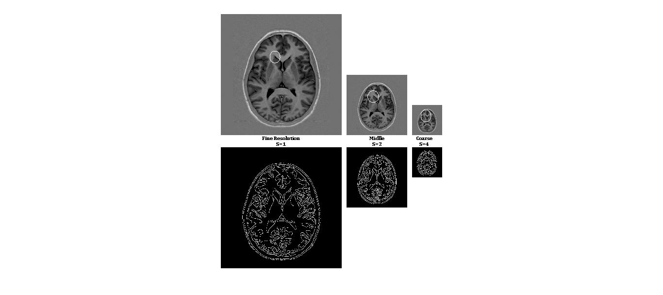

Fig. 1. Computation procedure of multiscale images features.

Fig. 1 demonstrates computation procedure of multi-scale feature extraction. As it is shown in this figure image is progressively downsampled and multiscaled instead of increasing the radius of the circle around the pixel and this would significantly save computation burden. Three levels of downsampling have been employed to cover all locality features including coarse, middle and fine resolutions. To boost the similarity between matching points, a boundary image came along with the intensity image to ease the registration procedure. Canny edge detector [15] is used to quantify the strength of boundary on each point. This boundary image helps us to accurately match the boundary of moving and static images. Then a short vector of local histogram moments will be saved to serve as similarity measurements. This attribute vector is replaced the whole histogram vector. Geometric moments as a statistical feature for each histogram defined as below:

$$m\left(v_{s},p\right)=\sum_{i}{i^{p}h_{s}\left(v_{s},i\right)} (1)$$

where $s=1,2,4$ is the three scaled version of original image. $h_{s}\left(v_{s},i\right)$ is the frequency of intensity *i* in histogram $h_{s}\left(v_{s}\right)$ and $m\left(v_{s},p\right)$ is the *p*th order moment. Considering $a_{s}^{Hist}\left(v\right)$ as a vector of first 6 moments of each scale, $a_{1}^{Hist}\left(v\right)$ contains most locally information where $a_{2}^{Hist}\left(v\right)$ and $a_{4}^{Hist}\left(v\right)$ contains mid-level and general information respectively. Considering these three scaled versions of attribute vectors along with the boundary versions, the attribute vector of a point *v* can be finally represented as:

$$a\left(v\right)=[\left[a_{1}^{Hist}\left(v\right) b_{1}^{Bound}\left(v\right)\right],\left[a_{2}^{Hist}\left(v\right) b_{2}^{Bound}\left(v\right)\right], \left[a_{4}^{Hist}\left(v\right) b_{4}^{Bound}\left(v\right)\right]] (2)$$

Each attribute has been normalized between 0 and 1. Comparing the similarity of attribute vectors, corresponding points of two images will be determined. The similarity of two attributes vectors, $a(u)$ and $a(v)$ of two points, *u* and *v,* are defined as follows:

$$m\left(a\left(v\right),a\left(u\right)\right)= \prod_{s}{((1-|b_{s}^{Bound}\left(u\right)-b_{s}^{Bound}\left(v\right) |)}*\prod_{i}{\left(1-\left|a_{s,i}^{Hist}\left(u\right)-a_{s,i}^{Hist}\left(v\right)\right|\right)}) (3)$$

where $a_{s,i}^{Hist}\left(u\right)$ is the *i*th element of ${ a}_{s}^{Hist}\left(u\right)$.

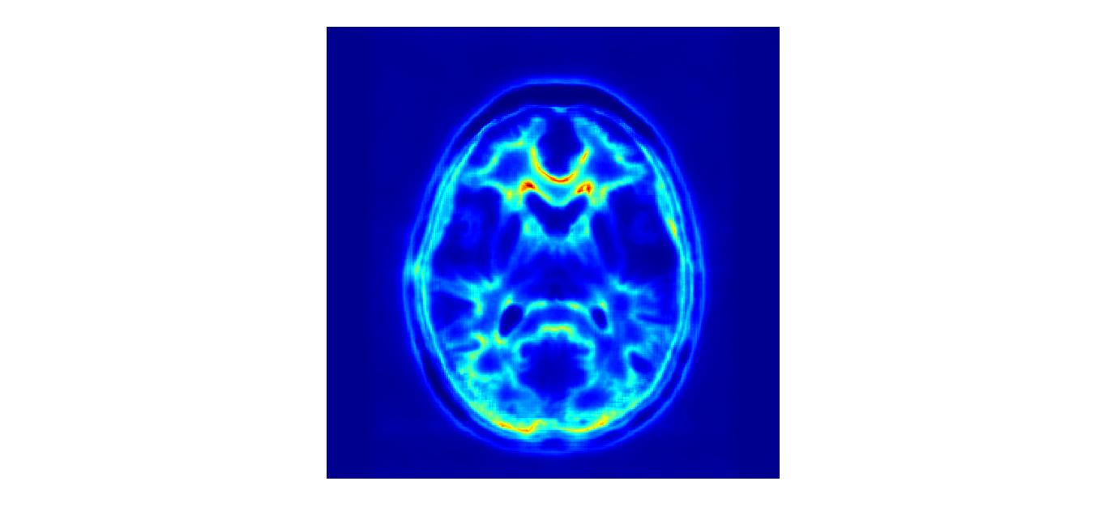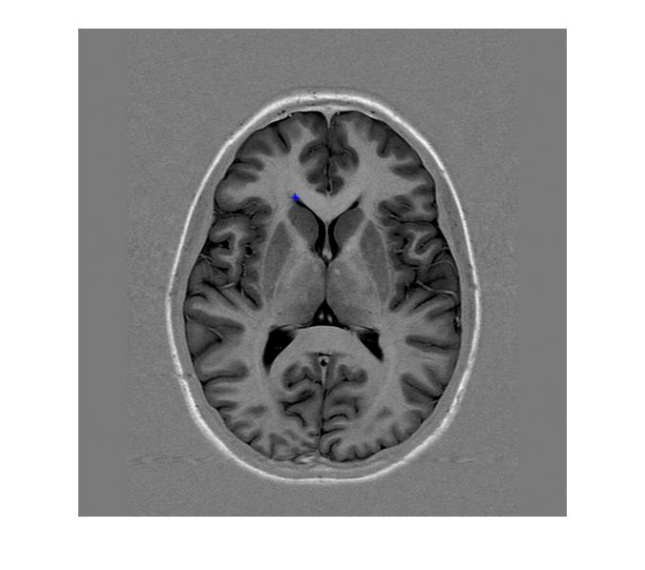

Fig. 2. Similarity measurement of crossed point in left with whole pixels of the same individual; result is shown in a color-coded map which red colour shows the maximum similarity with reference point.

Fig. 2 illustrates the similarity measurement between crossed point in the left image with the whole pixels of same individual and the result is shown in a color coded map in right which the red color means the maximum similarity. It was predictable to see a maximum similarity in a small neighborhood and the symmetric region in a MR brain image. The result indicates that the histogram-based attribute vectors have an efficient ability in discriminating points.

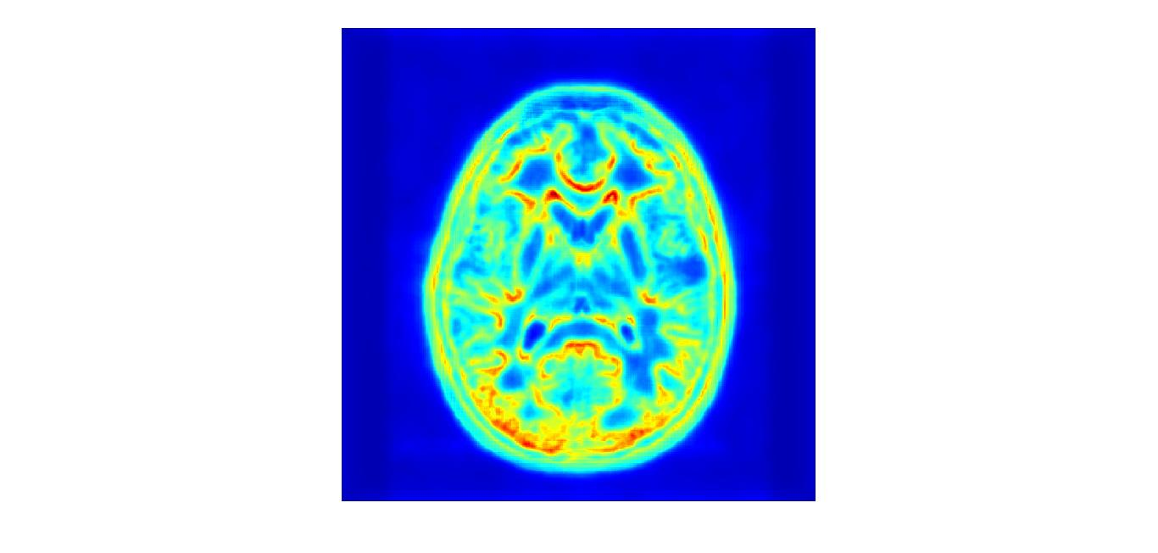

Fig. 3. Similarity measurement of the crossed point in Fig. 2. by using only 2 moments.

As it is shown in Fig. 3, using an improper quantity of moments could cause a wide range of similarity. Instead, we used first six moment of the histogram which help us to distinguish points appropriately. Also Fig. 4 emphasize role of meltiresolutioning using only the middle resolution.

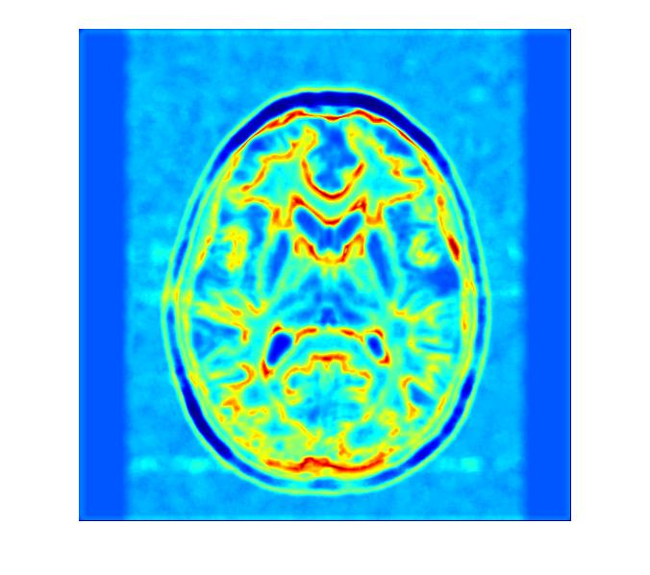

Fig. 4. Similarity measurement of the crossed point in Fig. 2. by using only middle scale instead of multi-scaled version.

1. Non-rigid B-spline transform

With $N$ pairs of corresponding points matched by similarity measurement described in attribute vector we have two set of points for static and moving image. Here it can be employed a free form deformation (FFD) based on B-spline as a point-based surface matching [14]. Here we have two set of points $X$ and $V$ and a spatial transformation, $T\left(V\right)$, which deforms a grid spread on static image to match each point in $X$, $X_{a}$, to its corresponding point in $V$, $V_{a}.$ Therefore, $T(V_{a})$ shows the exact position of $X_{a}$ instead of its displacement field. To reach the transformation formulation we have to define our domain space for an image the domain space would be:

$$Ω=\left\{\left(x,y\right) | 0≤x<X,0≤y<Y\right\} (4)$$

Let set a mesh, $ϕ$, with the size of $n_{x}×n_{y}$ and name these points as its control points; the points are uniformly distributed. A FFD can be written as a 2-D tensor product of 1-D B-spline:

$$T\left(x,y\right)=\sum_{l=0}^{3}{\sum_{m=0}^{3}{B_{l}\left(u\right)B_{m}\left(v\right)ϕ_{i+l,j+m}}} (5)$$

Where $j=\left\lfloor \frac{y}{n_{y}}\right\rfloor -1, i=\left\lfloor \frac{x}{n_{x}}\right\rfloor -1,u=\frac{x}{n_{x}}-\left\lfloor \frac{x}{n_{x}}\right\rfloor$ and $v=\frac{y}{n_{y}}-\left\lfloor \frac{y}{n_{y}}\right\rfloor$. Also $B_{l}$ represents the *l*th basis function of the B-spline. Each point is computed as a summation of transformation values in all points. In addition we could use a penalty term to control the smoothness of the deformation; this term restrict the algorithm to control the displacement field of each point. The general form of such a penalty term has been described by Wahba [16].

$$C_{smooth}=\frac{1}{S}\int_{0}^{X}{\int_{0}^{Y}{[{\left(\frac{d^{2}T}{dx^{2}}\right)}^{2}+{\left(\frac{d^{2}T}{dy^{2}}\right)}^{2}+2{\left(\frac{d^{2}T}{dxy}\right)}^{2}]dxdy}} (6)$$

where S shows the image area.

Table 1. demonstrates a step-by-step procedure of the algorithm.

TABLE I :Automatic Histogram-based Landmarks Extraction and Reduction coped with B-spline Registration

|  |  |
| --- | --- |
| **Algorithm** | |
| read two images;  static image multi-resolution and edge creation;  create features for each points of images in *2*;  **while** (*difference of two images $<$ pre-defined error*) **do**  moving image multi-resolution and edge creation;  create features for each points of images in *5*;  normalize features of *3* & *6 $;$*  define base point set;  find correspondent points of defined base points;  **if (** *distance(base, correspondent) < desired distance* **)**  keep base points and correspondent points;  **else**  delete base points and correspondent points;  **end if;**  apply B-Spline transform by remained;  moving image $←$ registered image  **end while;**  show the results; | 1 :  2 :  3 :  4 :  5 :  6 :  7 :  8 :  9 :  10:  11:  12:  13:  14:  15:  16:  17:  18: |

III – Results & Evaluation

Five brain MR images are used as static image to evaluate the algorithm. Each image has transformed by a locally non-rigid manner to obtain moving images. One sample of our database is shown in figure 4. Canny edge detector has been employed to construct the boundary map. The radius in feature extraction level has been set to 8 pixels. This value is constant for all resolutions to implement a general view at first steps of algorithm and a detailed view at final levels.

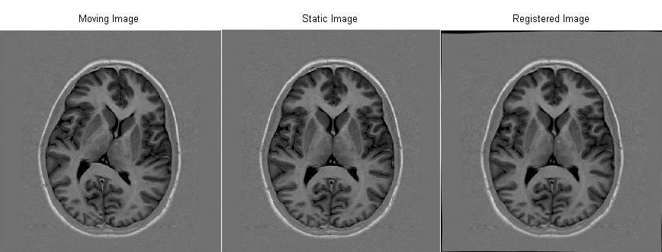

Fig. 5. Similarity measurement of the crossed point in Fig. 2. by using only middle scale instead of multi-scaled version.

Setting radius value has a significant influence on speed of converging. 8 pixels guaranty reliable results with acceptable speed. The histogram bins have been set to 32 bins in order to have a fine estimation. A 16×16 grid map with constant distance of points has been utilized to estimate the transform by B-spline method. Figure 5 shows the final result of proposed registration process of two depicted images in figures 5(a) and 5(b) which is obtained after 6 iteration of method.

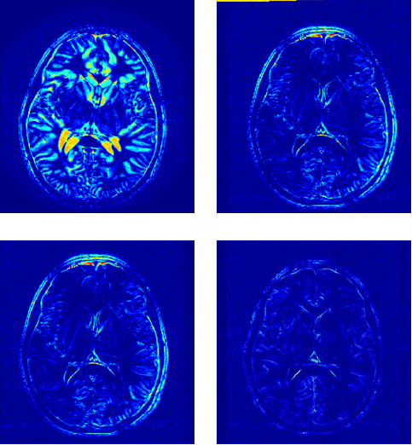

Fig. 6: Top left is the error between moving and static image top right is the thin plate spline registration with nearest neighbour interpolation; bottom left is Bilinear-Thin plate spline registration and bottom right is Automatic Histogram based image registration

Figure 6 illustrates the colour-map of difference between results and original sample brain MR images. The square value of difference between original image and (a) distorted image, (b) thin plate spline (TPS) with nearest neighbour interpolation registration result, (c) TPS with bilinear interpolation result and finally (d) proposed method’s registration result have been depicted in this figure. The average values of normal mean square error between the registered and original images for all three methods are shown in table 2. All evaluation approaches have shown significant improvement of registration results for proposed algorithm.

TABLE III: Average Value of NMSE for 5 Images

|  |  |
| --- | --- |
| Method | NMSE |
| TPS with nearest neighbour interpolation | **0.0029** |
| TPS with bilinear interpolation | **0.0032** |
| Proposed method | **0.0015** |

The NMSE value for 15 iterations of the proposed algorithm is illustrated in figure 7. This curve proves the acceptable speed of the method.

Fig. 7 NMSE value for 15 iterations of proposed algorithm

III – Conclusions

Considering non-rigid distortion in brain MR images, a new image registration method is introduced to reconstruct the image. The proposed registration process is based on automatic landmark detection using local histogram of the image. A multi-resolution approach with B-spline non-rigid registration method has been employed. The results have shown improvement in accuracy of registration in comparison with thin-plate spline approach.

References

1. R. Gan, A.C.S. Chung, Multi-dimensional mutual information based robust image registration using maximum distance-gradientmagnitude, IPMI’05, Glenwood Springs, Colorado, USA, July 10–15, 2005, Lecture Notes in Computer Science, vol. 3565, pp. 210–221.
2. D. Rueckert, L.I. Sonoda, C. Hayes, D.L.G. Hill, M.O. Leach, D.J. Hawkes, Nonrigid registration using free-form deformations: application to breast MR images, IEEE Trans. Med. Imaging 18 (8) (1999) 712–721.
3. R. Bajcsy, R. Lieberson, M. Reivich, A computerized system for the elastic matching of deformed radiographic images to idealized atlas images, J. Comput. Assisted Tomography 7 (4) (1983) 618–625.
4. H. Chui, L. Win, R. Schultz, J. Duncan, A. Rangarajan, A unified feature registration method for brain mapping, Inf. Process. Med. Imaging 2001, pp. 300–314.
5. M. Vaillant, C. Davatzikos, Hierarchical matching of cortical features for deformable brain image registration, Lecture Notes in Computer Science: Information Processing in Medical Imaging, vol. 1613, June 1999, pp. 182–195.
6. K. Rohr, Image registration based on thin plate splines and local estimates of anisotropic landmark localization uncertainties, Lecture Notes in Computer Science: MICCAI’98, vol. 1496, 1999, pp. 1174–1183.
7. D. Shen, C. Davatzikos, HAMMER: hierarchical attribute matching mechanism for elastic registration, IEEE Trans. Med. Imaging 21 (11) (2002) 1421–1439.
8. D. Shen, “Image registration by local histogram matching,” Pattern Recognition. , vol. 40, pp. 1161–1172, 2007
9. L. Yonghong, C.H. Davis, “Pixel-Based Invariant Feature Extraction and its Application to Radiometric Co-Registration for Multi-Temporal High-Resolution Satellite Image,” IEEE Journal of selected Topics in Applied Earth Observations and Remote Sensing, vol 4, no. 2, pp. 348- 360, 2010..
10. D. K. Iakovidis, N. Pelekis, E. E. Kotsifakos, I. Kopanakis, H. Karanikas, Y. Theodoridis, “A Pattern Similarity Scheme for Medical Image Retrieval,” IEEE Trans. Inf. Tech. in Med., vol. 13, no. 4, pp. 442-450, 2009.
11. R. M. Palenichka, M. B. Zaremba, “Automatic Extraction of Control Points for the Registration of Optical Satellite and LiDAR Images,” IEEE Trans. Geo. Remote Sensing, vol. 48, no. 7, pp. 2864-2879, 2010
12. Sh. Liao, A. C. S. Chung, “ Feature Based Nonrigid Brain MR Image Registration With Symmetric Alpha Stable Filters,” *IEEE Trans. Med. Imag.,* vol. 29, p106-119, 2010.
13. R. Abbasi-Asl, E. Fatemizadeh, “MMRO: A Feature Selection Criterion for MR Images Based on Alpha Stable Filter Responses,” IEEE Proceedings of 7th Conference on Machine Vision and Image Processing, Tehran, Iran, 2011.
14. D.Rueckert, L.I.Sonoda, C.Hayes, D.L.Hill, M.O.Leach, and D.J.Hawkes, "Nonrigid registration using free-form deformations: application to breast MR images," IEEE Trans Med Imaging, vol. 18, pp. 712-721, 1999.
15. J. Canny, A computational approach to edge detection, IEEE Trans.PAMI 8 (6) (1986).
16. G. Wahba, “Spline models for observational data,” Soc. Industr. Applied Math., 1990.